Presbytery of the Northern Plains
5555 South Washington Street ~ Grand Forks, North Dakota 58201
(701) 772-0783 or (800) 243-3532 Fax (701) 775-7599
www.northernplainspresbytery.com

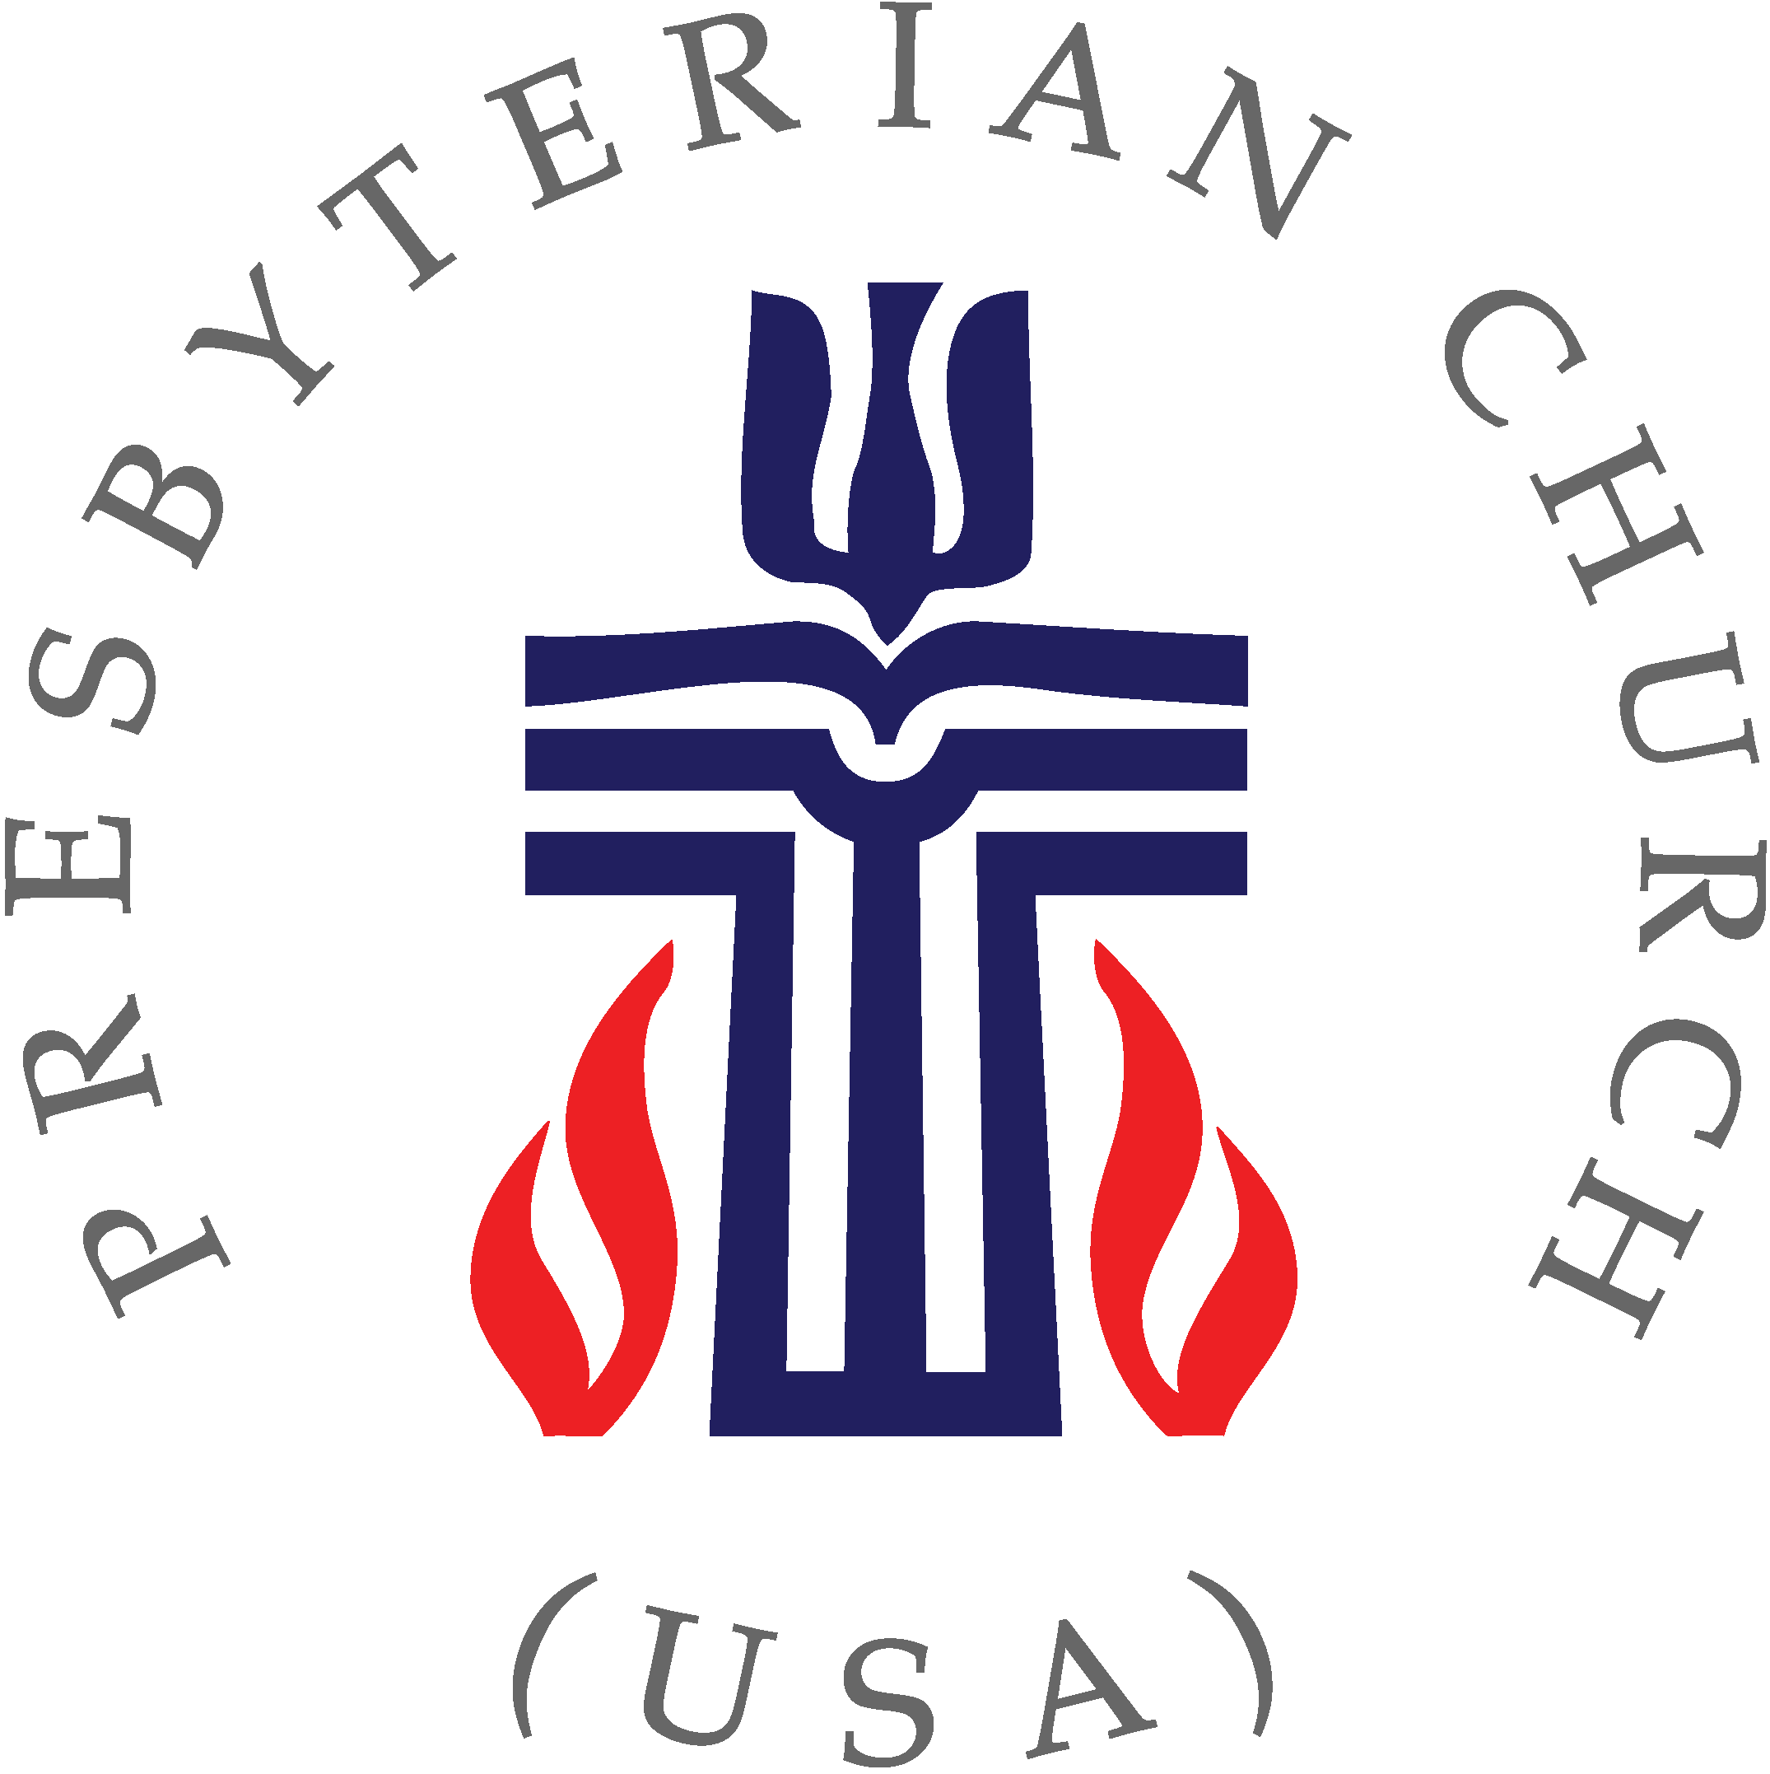

Moderator
Tom Brusegaard
701-780-1105
gilbyguy@gmail.com

Vice Moderator
Sylvia Pringle
701-320-0190 (cell)
mamachips1@gmail.com

Stated Clerk
Michael Lochow
701-200-6794 (cell)
sc.pbynp@gmail.com

Treasurer
Ellen Misialek
701-520-3220 (cell)
emisialek@invisimax.com

CALL FOR THE APRIL 2022
PRESBYTERY MEETING

The One Hundred Twenty-Sixth Stated Meeting of the Presbytery of the Northern Plains will be held in a hybrid format: both in person and via Zoom video conferencing, on Saturday, April 2, 2022, beginning at 10:00 a.m.

Even as the pandemic begins to slow, we will continue to offer joining the meeting via Zoom as an option. Link for the Zoom call
https://us02web.zoom.us/j/89039138362pwd=dDROK2RnRmpNYlJyT05PNEhkVzNlQT09 PASSCODE: Passcode: 682324

The Zoom link will open at 9:00 a.m. for registration and to offer any assistance commissioners or other attendees need in setting up their computers. If you need assistance, you can connect Jamie Norstog at the Presbytery office email: pnpoffice@gmail.com.

The meeting will cover several important topics and it important that you join us to offer your thoughts. The agenda includes the following:

- Presentations by TE Deb DeMeester, director of leadership development at the Synod
- Reading of the Necrology for 2021
- Reports from various ministry teams: Chogoria and Youth
- Good News from the Commissioners
- Closing Commission for the Inkster Presbyterian Church

Presbytery meeting materials will be posted and available on the Presbytery website at www.northernplainspresbytery.com to download. You are reminded that there will be no hard copies of the reports, so it is essential that you visit the Presbytery website and read and/or download the reports. Check more than once as reports may be added closer to the meeting date. If you have any questions or concerns, please feel free to contact the Presbytery office at 701-772- 0783, by email or the Stated Clerk.

