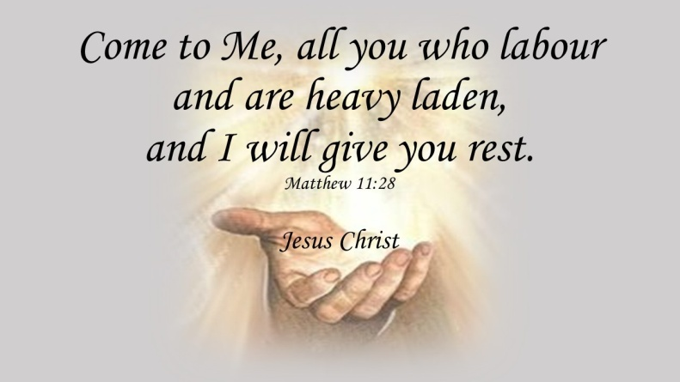

An Overview of the 2022-2023
PW/Horizons Bible Study

2022 SPRING GATHERING
OF PRESBYTERIAN WOMEN OF THE PRESBYTERY OF NORTHERN PLAINS

On Saturday, April 30, 2022
At First Presbyterian Church, Colgate, ND
With Registration at 10:00 a.m.
For a Cost of $15.00 payable to PWP
RSVP by April 25 to Lana Schultz
at 701.238.4538 or lanaj0@casselton.net

Items being collected for mission are:
$10 Gift Cards for: All About You Adoptions to build families & Lila Mae’s House to empower survivors of sex trafficking
AND
School Bags made from Gift of Heart kit pattern for Presbyterian Disaster Assistance

